Using the ISA 2006 Firewall to Publish OWA Sites – Single Exchange Server

The new ISA firewall includes a number of new features that represent improvements over the ISA 2004 firewall Web Publishing feature set.
To demonstrate some of the changes included with the new ISA firewall, we’ll go over how to publish a single back-end Exchange Server where there are no front-end devices. This provides a simple environment that you can use to test the new ISA firewall and get a taste for the new features it provides to enhance the security of remote access connections to Exchange Server Web services.
The figure below provides a high level view of the example network.
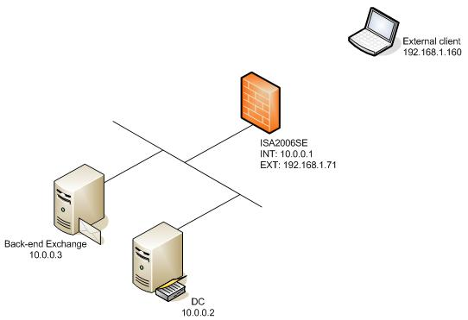
Figure A
Key facts about the network setup include:
- All machines are part of the same domain. This is an ISA firewall best practice and we keep with best practices around here. I know there might be some moaning from the low brows that maintain the routers on the network, but router people are not security experts. However, we are.
- On the DC computer are installed Active Directory, DHCP, DNS, Certificate Services and WINS. Not all of these services are required in this scenario, but they all can be leveraged by the ISA firewall in a number of different scenarios. In the current scenario, only the DHCP, DNS, Active Directory and enterprise CA services will be used. WINS is primarily used to support VPN client connections where the VPN client machines are not domain members and thus cannot fully qualify unqualified names correctly
- A Web site certificate was generated for the back-end Exchange Server’s OWA Web site using the Web Site Certificate Wizard included with IIS to request the certificate from an online enterprise CA
- The name of the Web site certificate bound to the OWA site is owa.msfirewall.org. This certificate was exported, along with its private key, to a file and then imported into the ISA firewall’s machine certificate store. This certificate will be bound to the Web listener that we’ll create later in this article.
- The CA certificate of the CA issuing the Web site certificate is installed on the ISA firewall. This will happen automatically if the ISA firewall was made a domain member before installing the ISA firewall software. If the ISA firewall was made a domain member after the ISA firewall software was installed, then you will have to go through a somewhat tedious procedure to benefit from certificate auto enrollment. The easiest was to do this is to import the CA certificate into the ISA firewall’s Trusted Root Certificate Authorities machine certificate store manually
- A split DNS is deployed to support users’ wishes to use the same name to connect to the OWA site regardless of location. This means that users will be able to use the same name to connect to the ISA firewall when they’re on the corporate network or when they’re located somewhere outside the office.
Once the DNS is configured and certificates are deployed, you’re ready to publish your OWA Server.
To create the Web Publishing Rule, open the ISA firewall console, expand the array name and click the Firewall Policy node. Click the Tasks tab in the Task Pane and click the Publish Exchange Web Client Access link.
On the Welcome to the New Exchange Publishing Rule Wizard page, enter a name for the rule in the Exchange Publishing rule name text box. In this example we’ll use the name OWA. Click Next.
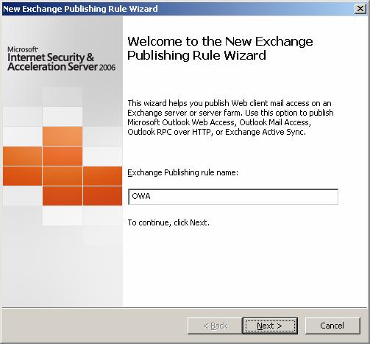
Figure 1
On the Select Services page, select the Exchange Server 2003 option from the Exchange version drop down list. Here you have the following options:
- Outlook Web Access
- Outlook RPC/HTTP(s)
- Outlook Mobile Access
- Exchange ActiveSync
In this scenario we’re only publishing the OWA site, but there’s no reason why you can’t select the other options. Select the Outlook Web Access option and click Next.
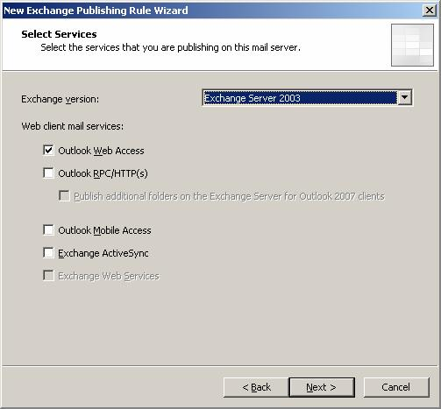
Figure 2
On the Publishing Type page, you have two options:
- Publish a single Web site or load balancer This option allows you to publish a single server that isn’t part of a Web farm, or if you have a third party load balancer behind the ISA firewall, then you publish that load balancer’s address. If you have a farm of front-end Exchange Servers, I highly recommend that you try to get a refund on your third party load balancer and use the integrated Web Farm support that comes with the new ISA firewall, as you’ll see better performance and reliability, as well as removing a single point of failure, which is what the third party load balancer represents.
- Publish a server farm of load balanced Web servers This option allows you to publish a Web farm of front-end Exchange Servers using the ISA firewall’s built-in Web Farm publishing capabilities. The built-in Web farm publishing feature provides excellent load balancing, failover and failback, and health monitoring.
In this example we’re publishing a single Exchange Server, so we’ll select the Publish a single Web site or load balancer option and click Next.
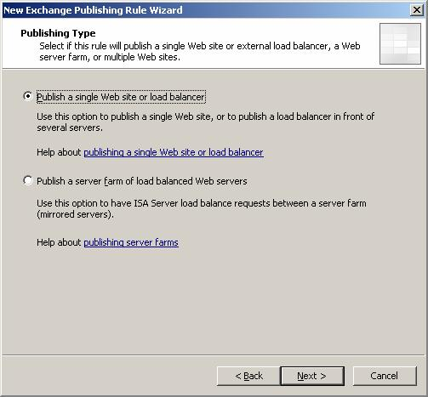
Figure 3
On the Server Connection Security page you have two options:
- Use SSL to connect to the published Web server or server farm This option tells the ISA firewall to use a secure SSL connection between itself and the published Web server. I highly recommend that you always use this option because no network can be trusted. Since no network can be trusted, you want to make sure that even communications moving over the corporate network are encrypted, and this is what this option provides you.
- Use non-secured connections to connect the published Web server or server farm This option tells the ISA firewall to use an unsecured link between itself and the published Web server. I strongly recommend that you do not use this option because the information between the ISA firewall and the published Web site will not be encrypted and can be easily accessed by anyone with a network sniffer on any interposed network between the ISA firewall’s internal interface and the published Web server.
In this example we’ll use ISA firewall best practices and force a secure SSL link between the ISA firewall and the published Web server. Select the Use SSL to connect to the published Web server or server farm option and click Next.
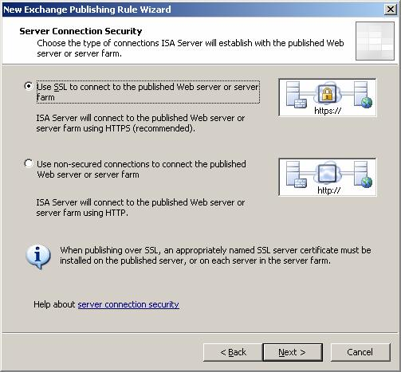
Figure 4
On the Internal Publishing Details page you enter information about the Web server that you’re publishing. In the Internal site name text box, you enter the common/subject name on the Web site certificate that is bound to the OWA Web site. You must do this because it's required for the CONNECT process between the ISA firewall’s internal interface and the published Web server. Failure to follow these instructions will lead to the dreaded 500 Server Error.
One major improvement included with the new ISA firewall is the ability to specify a name or IP address of the published Web server. In ISA 2004, the name on the To tab was used both to resolve the name of the published server on the internal network and also provide the name used in the CONNECT.
This was problematic because the name on the Web site certificate bound to the OWA site is almost never the actual name of the server (nor should it be). Because of this, you had to either deploy a split DNS (which you should do anyhow) or enter a HOSTS file entry on the ISA firewall that resolved the common/subject name on the OWA Web site’s certificate to the IP address of the published Web server.
With the new ISA Server 2006 firewall, you don’t have to go through these hoops. The name used for the CONNECT is the one entered in the Internal site name text box and the connection request is sent to the IP address or name you enter in the Computer name or IP address text box after putting a checkmark in the Use a computer name or IP address to connect to the published server. This does simplify things a bit, but I still highly recommend a split DNS infrastructure to support your users who move between the internal and external networks with their laptops.
In this example, the common/subject name on the Web site certificate bound to the OWA Web site is owa.msfirewall.org so we enter that name in the Internal site name text box. The IP address of the machine is 10.0.0.3, so I enter that into the Computer name or IP address text box. Note that if we were using User Certificate authentication in this scenario and Kerberos Constrained Delegation, we would need to enter the actual FQDN of the internal Exchange Server.
Click Next.
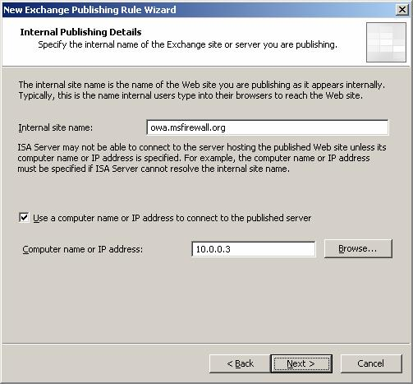
Figure 5
On the Public Name Details page, select the This domain name (type below) option from the Accept request for drop down list. You always want to select this option when publishing Web sites. If you select the Any domain name option, you can potentially increase your attack surface, which is something we really don’t want to do.
In the Public name text box, enter the common/subject name of the Web site certificate that will be bound to the Web listener used in this Web Publishing Rule. In this example, we are going to bind the Web site certificate that we bound to the OWA Web site itself, so it will use the same common/subject name as the internal Web site, which in this case is owa.msfirewall.org.
Click Next.
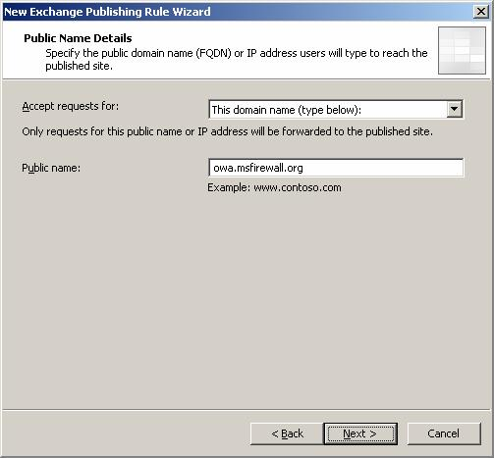
Figure 6
On the Select Web Listener page you can select a Web Listener that you’ve already created or create a new one. Since we haven’t created a Web Listener yet, we’ll click the New button to create the new Web listener.
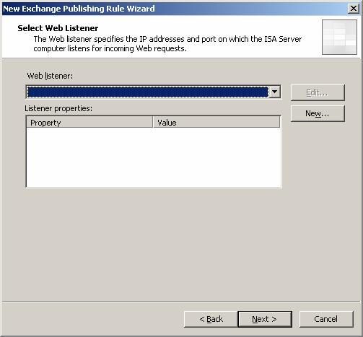
Figure 7
On the Welcome to the New Web Listener Wizard page, enter a name for the Web Listener. In this example, we’ll name the Web Listener OWA SSL Listener and then click Next.
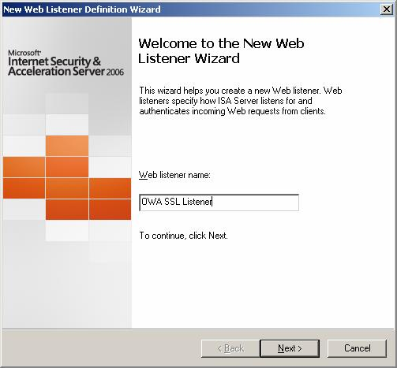
Figure 8

On the Client Connection Security page, you have two options:
- Require SSL secured connections with clients This option tells the ISA firewall that you want to require the external clients to use a secure SSL connection to connect to the external interface of the ISA firewall. This is the option you should select in almost all cases except for the scenario where you are publishing a central OWA server from branch office locations. Failure to enforce SSL connections from external clients to the external interface of the ISA firewall
- Do not require SSL secured connections with clients This option enables the use of an unsecure connection between the client and the external interface of the ISA firewall. Do not use this option.
In this example we’re using ISA firewall best practices, so we’ll select the Require SSL secured connections with clients and click Next.
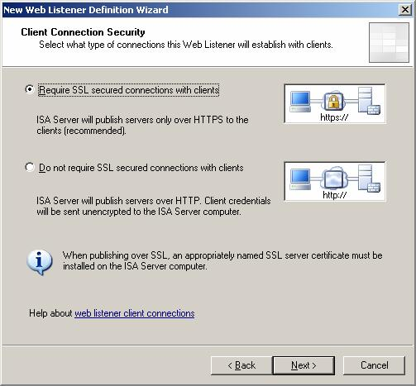
Figure 9
On the Web Listener IP Address page you select what ISA firewall Networks and IP addresses on which you want the ISA firewall to accept incoming connections. In our example, we want both external users and internal users to be able to access the OWA site. To do this, we put checkmarks in the External and Internal checkboxes. Note that we have a split DNS infrastructure already configured that will support using the same name regardless of the users location.
If you have multiple IP addresses bound to any interface on the ISA firewall, you should click the Select IP Addresses button and select the specific IP address on which you want the listener to accept the incoming connections. This increases your options, because if you configure the Web Listener to listen on all IP addresses, you can’t create any other listeners because the SSL socket will already be bound to all the addresses.
In this example we only have one IP address bound to each interface, so we’ll select the External and Internal Networks and click Next.
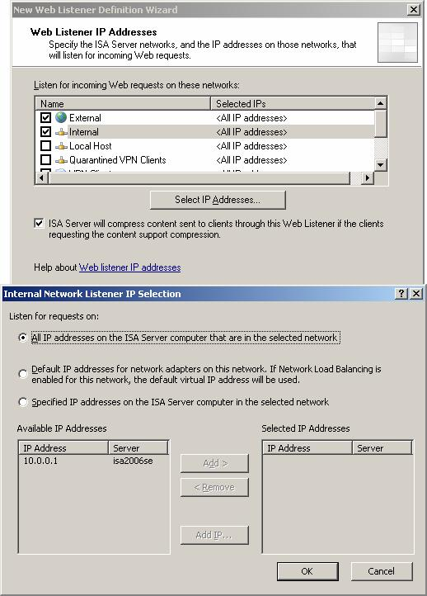
Figure 10
On the Listener SSL Certificates page, you select the certificates that you want bound to the Web listener. In our current example we only have a single certificate. However, we could use this listener to publish multiple Web sites using different common names and bind all of those certificates to this listener. This is useful for a single sign-on environment where you want the OWA users to have access to a published SharePoint Portal Server site without having the users log in again.
Note that in the scenario where you want to bind multiple certificates to the Web listener, the Web Listener must be listening on more than one IP address, as you can only bind a certificate to a single IP address.
In this example, click the Select Certificate button. In the Select Certificate dialog box, you’ll see a list of certificates that can be used in the Web Publishing Rule. This dialog box will also provide you with information about the validity of the certificate, whether the certificate will expire soon, and more information. When you put a checkmark in the Show only valid certificates checkbox, you’ll only see certificates that are valid to bind to your Web listener.
In our current scenario, we’ll select the owa.msfirewall.org certificate and click Select.
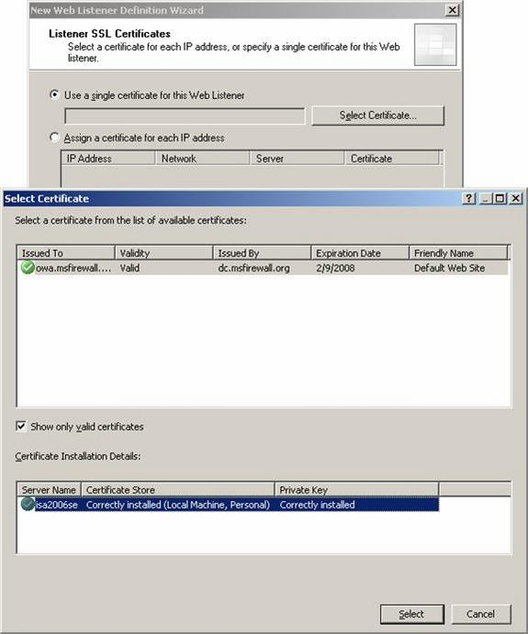
Figure 11
Click Next on the Listener SSL Certificates page.
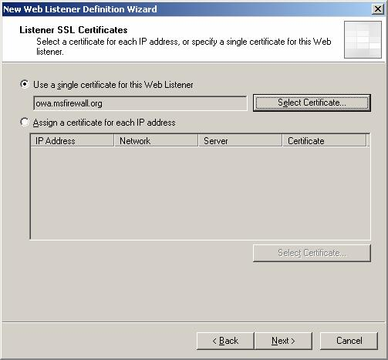
Figure 12
On the Authentication Settings page you have a number of options. However, you’ll always want to select the HTML Form Authentication option from the Select how clients will provide credentials to ISA Server drop down list when publishing OWA sites.
Note the Collect additional delegation credentials in the form option. You enable this option when using RADIUS OTP or RSA SecurID authentication.
The Select how ISA Server will validate client credentials list of options includes:
- Windows (Active Directory) Use this option when the ISA firewall is a member of the domain. This is the most secure and flexible option
- LDAP (Active Directory) Use this option when the ISA firewall is not a domain member, but you want to leverage Active Directory groups for access control
- RADIUS Use this option when the ISA firewall is not a domain member, and you don’t need to leverage Active Directory groups (because you won’t be able to when using RADIUS authentication). This is the least secure and lowest performing option.
- RADIUS OTP Use when you have a third party RADIUS one-time password solution in place.
- RSA SecurID Use when you have deployed RSA SecurID two-factor authentication solution.
In this example, we’re using ISA firewall best practices and the ISA firewall is a domain member, so we can fully leverage the security and flexibility that domain membership provides. In this case, we’ll select the HTML Form Authentication option and the Windows (Active Directory) option and click Next.
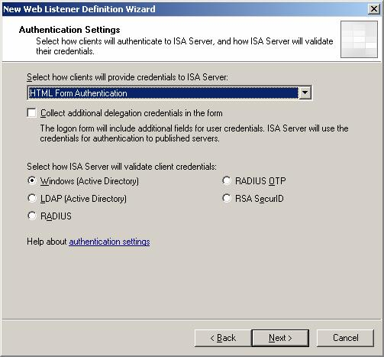
Figure 13
Before moving to the next step, you’ll probably want to know more information about the authentication methods available and what you can do with them. The authentication method you select determines that types of authentication delegation methods available to you. The figure below provides that information. In a future article I’ll break down this table and give you some insights into what this information actually means in a production environment.
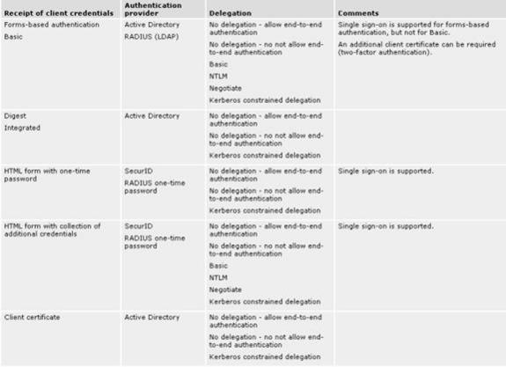
Figure 14
On the Single Sign On Settings page, put a checkmark in the Enable SSO for Web site published with this Web listener checkbox. This option enables you to publish multiple Web sites belonging to the same domain and have single sign-on for each of those sites. In contrast to ISA 2004, where you had to log into each Web site, even if they are in the same domain, when you enable SSO in ISA Server 2006, once the user has logged onto one Web site using a particular Web listener, then all other sites published with that same Web Listener will be enabled for SSO.
In this example, we’re not publishing multiple Web sites. However, if we we’re, the SSO domain would be msfirewall.org. So we’ll enable the checkbox and enter .msfirewall.org in the SSO domain name checkbox and click Next.
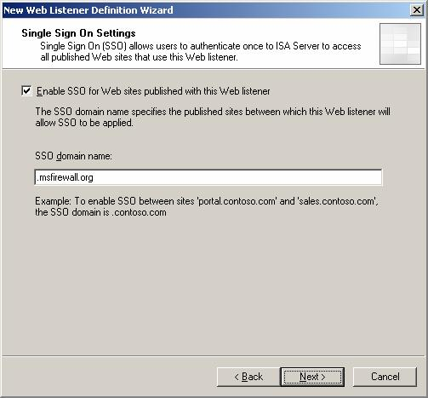
Figure 15
Click Finish on the Completing the New Web Listener Wizard page.
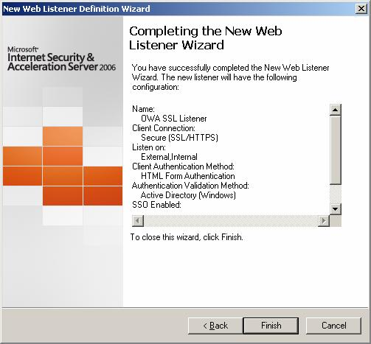
Figure 16
Click Next on the Select Web Listener page.
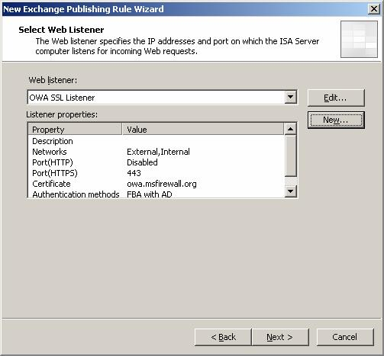
Figure 17
On the Authentication Delegation page you select how you want to delegate credentials to the published Web site. Authentication delegation enables the ISA firewall to pre-authenticate the user before forwarding the user credentials to the destination Web site. The type of delegation the ISA firewall can perform depends on how the user authenticated with the ISA firewall.
You have the following options when HTML form based authentication is used by the Web listener:
- No delegation, and client cannot authenticate directly This option allows the ISA firewall to authenticate the user, but does not forward the use credentials to the published Web server and does not allow the client to authenticate with the Web server, even if the Web server requests authentication. Use this option when you only want the external clients to authenticate with the ISA firewall, but not the published Web server.
- No delegation, but the client may authenticate directly This option allows the ISA firewall to authenticate the user, but the ISA firewall will not forward the credentials to the destination Web server. However, in this case, if the destination Web server challenges the client for credentials, the client will be allowed to provide these credentials.
- Basic authentication This option allows the client to authenticate with the ISA firewall and then the ISA firewall forwards the credentials as basic authentication credentials to the destination Web server. When using this method, make sure you always deploy SSL to SSL bridging, so that the credentials are not captures on the link between the ISA firewall’s internal interface and the published Web server.
- NTLM authentication This option allows the client to authenticate with the ISA firewall and then forward the credentials as NTLM credentials to the published Web server. This is a more secure option than basic delegation, as the actual credentials are not forwarded over the wire between the ISA firewall’s internal interface and the published Web server. However, this should be used only in circumstances where NTLM can be used at the destination Web server. In the OWA example, at this time you must use Basic authentication to authenticate with the /Exchange directory. This might change in the future, but at this time the Exchange group considered using NTLM an unsupported configuration.
- Negotiate (Kerberos/NTLM) This option allows the client to authenticate with the ISA firewall and then negotiate Kerberos or NTLM authentication with the published Web server. The scenarios where this is applied are similar to those in the NTLM delegation scenario.
- Kerberos constrained delegation This option allows the client to authenticate with the ISA firewall using a User Certificate. After authenticating with a User Certificate, the users’ credentials are passed as Kerberos credentials on the behalf of the ISA firewall. The ISA firewall must be configured to be trusted for delegation
In our current scenario of publishing an Exchange 2003 OWA Web site, the correct option to select is Basic authentication. The reason for this is that the Exchange team officially supports only Basic authentication to the /Exchange folder. This might change in the future, but right now we should use Basic delegation in this scenario. Select the Basic authentication option and click Next.
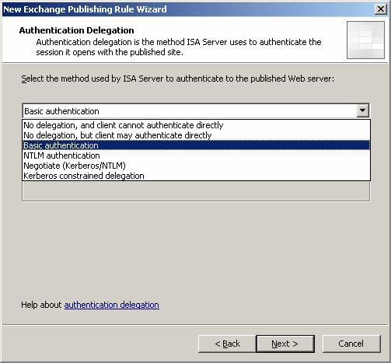
Figure 18
On the User Sets page, you can accept the default setting All Authenticated Users or you can create custom groups that should have access to the OWA site. In this example we’ll select the default option, but if you’re company wants to limit access to selected users, you can use the Add button to select domain Global Groups, or you can create your own custom ISA firewall Groups if you want to create custom user groups that aren’t defined in the Active Directory.
Click Next.
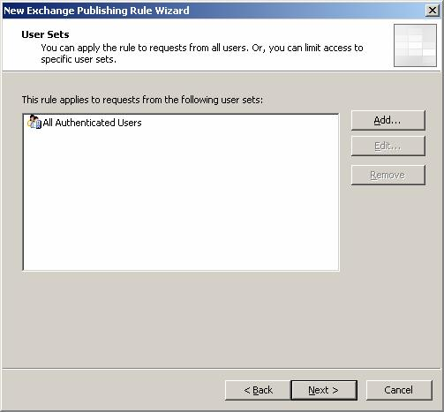
Figure 19
Click Finish on the Completing the New Exchange Publishing Rule Wizard page.
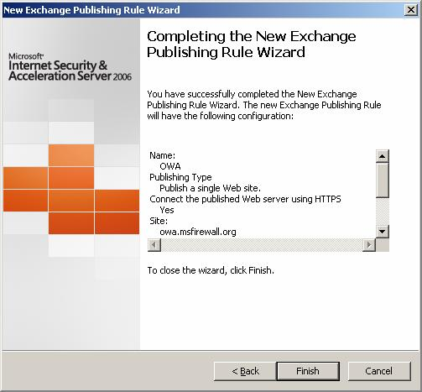
Figure 20
Click Apply to save the changes and update the firewall policy. Click OK in the Apply New Configuration dialog box.
In this, part 2 of the two part series, we’ll finish up by investigating things we can do to customize the Web Publishing Rule to increase security for the published OWA site. We’ll then finish up by reviewing the end-user experience for viewing the OWA site using the full and watered-down versions of OWA and how the user changes his password using the OWA interface.

Customizing the OWA Web Publishing Rule
At this point the OWA Web Publishing Rule will work and users will be able to connect to the OWA Web site using this rule. However, there are some things you can do to tweak the rule. Double click on the OWA rule.
In the OWA Properties dialog box, click the To tab. Here you have the option to specify how the ISA firewall proxies the connections to the published OWA Web site. The default setting is Request appear to come from the ISA Server computer. However, if you want to record the original client IP addresses in your Web server log files, you can select the Requests appear to come from the original client. Note that if you choose for the ISA firewall to preserve the original client IP address, then the published Web server must be configured as a SecureNET client.
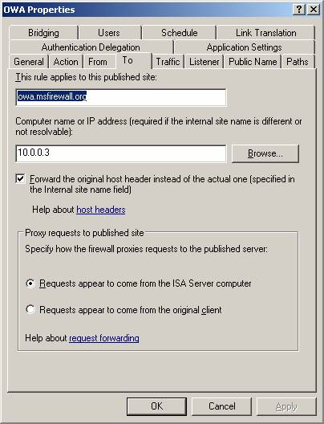
Figure 1
Click on the Traffic tab. Here you have two options:
- Require 128-bit encryption for HTTPS traffic This option allows you to force the clients to use 128bit encryption when connecting to the ISA firewall. Almost all modern browsers are capable of this, but if you want to make sure that no one is able to use an older browser that isn’t capable of 128bit encryption, then you can force that setting here.
- Require SSL Client Certificate This option allows you to require that the user provide a valid User Certificate before being able to log into the OWA site. The User Certificate must be for the same user who plans on logging into the site via the form.
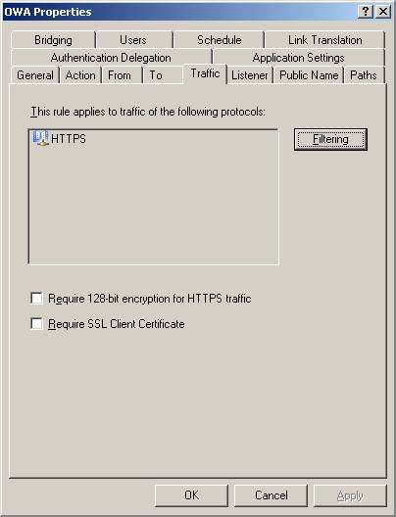
Figure 2
Click on the Application Settings tab.
Here you can change the Logon type provided to the Exchange Server, where the choices are:
- As selected by user (public or private)
- Always public
The option you select here is important in the context of the options you select in the Exchange Publishing Attachment Blocking frame. Here you have the option to block e-mail attachments for clients connecting from Public and/or Private computers.
While it’s nice to have the option to block attachments from public computers but allow them for private computers, the problem is that the ISA firewall doesn’t have a mechanism to determine what machines are public or private. The decision is up to the user. So, you could select the option to block attachments from public computers but allow them for private computers only to have users connecting from public kiosks select the private computer option.
I suppose you could set the option to Always public in the Logon type provided to the Exchange Server drop down box and it would prevent all users from accessing attachments. Only the other hand, you would just select the two checkboxes. So, it’s not really clear why you would care what log on type the user uses if you’re concerned about users violating your trust that they will select the correct logon type.
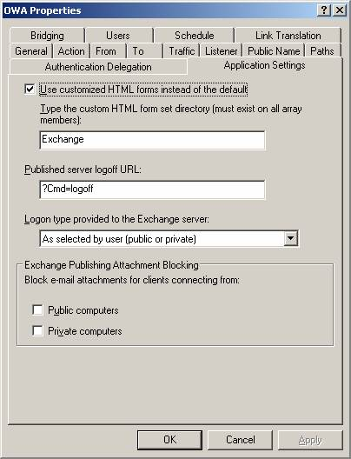
Figure 3
Click on the Listener tab and the click the Properties button. In the Listener’s Properties dialog box, click on the Forms tab. In the Password Management frame, you have the option to provide your users the ability to change their passwords and to be reminded to change their passwords “X” number of days in advance by using the Allow users to change their passwords and Remind users that their password will expire in this number of days options.
Click on the Advanced button on the Listener’s Properties dialog box and you’ll see some options regarding the use of persistent cookies, private cookies and session timeouts.
Persistent cookies allow the client to use the same cookie across applications and provides a better end user experience, but is less secure because the cookie can potentially be stolen. The default setting is to allow persistent cookies only on private machines. This answers the question I had above regarding what the point was regarding whether you should give users the option to select the type of client they have. The Public versus Private computer setting not only controls attachment behavior, but also controls cookie persistence. Your other two options for Persistent Cookies are Never use persistent cookies and On all computers.
The Ignore browser’s IP address for cookie validation option allows clients to use the same cookie from different IP addresses, such as when the client is located behind a load balancer that reports different source IP addresses for the connections to the ISA firewall’s external interface.
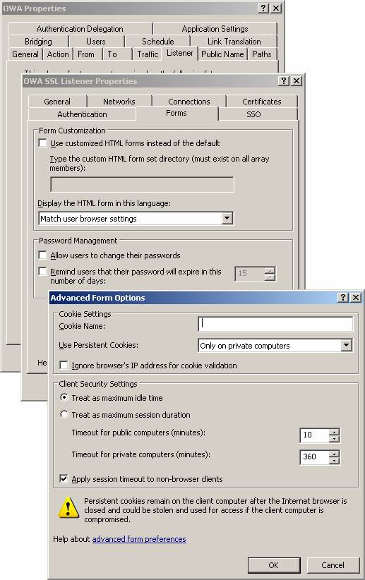
Figure 4
The Client Security Settings frame in the above graphic allow you to configure the session timeout. The default is set as the maximum idle time that is configured on the Web listener. You can customize this setting by selecting the Treat as maximum session duration and then setting customer time limits for public computers and private computers. You also have the option to Apply session timeout to non-browser based clients such as Outlook RPC/HTTP clients and ActiveSync clients. If you do not enable this option, I assume the session timeout will be the same as the maximum idle time and that no session timeout is set that would force a disconnect.

HTTP Security Filter Settings
While pre-authentication and authorization are important security functions the ISA firewall provides for protecting your OWA site, the ISA firewall can do much more. Specifically, the ISA firewall can make sure that potentially dangerous HTTP communications are not passed through the ISA firewall to the published Exchange Server’s OWA site. The ISA firewall is able to do this using to key technologies:
- SSL to SSL bridging (SSL termination and initiation)
- The HTTP Security Filter
SSL bridging enables the ISA firewall to inspect the contents of an otherwise encrypted tunnel. Unlike hardware firewalls that are unable to view the contents of an SSL tunnel and pass exploits contained in that tunnel to the Web server behind the “hardware” firewall, the ISA firewall is able to crack open the SSL tunnel, perform application layer inspection on the contents, and then re-encrypt the communication so that its forwarded over a secure SSL tunnel to the published Web server.
The HTTP Security Filter does the ISA firewall’s HTTP inspection for potentially dangerous communications that might move over the SSL connection. Because we know what “known good” communications are when connecting to the OWA site, we can configure the HTTP Security Filter to confirm that the connection meets those parameters and if the connection does not meet those parameters, then the connection is dropped.
To configure the HTTP Security Filter, right click the OWA rule and click the Configure HTTP command. This will bring up the Configure HTTP policy for rule dialog box as appears in the figure below.
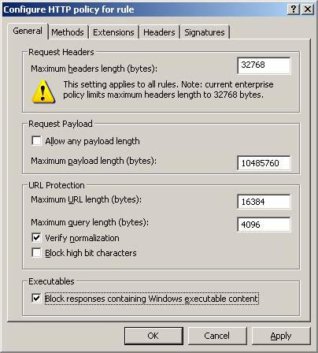
Figure 5
The table below provides the information you need to complete the configuration of the HTTP Security Filter for a OWA Web Publishing Rule. This information was obtained from the Microsoft article Application Layer Firewall protection for Exchange Server 2003 with ISA Server 2004 found at http://www.microsoft.com/technet/prodtechnol/isa/2004/plan/firewall-exchange2003.mspx
Setting and rule | Outlook Web Access
General tab
Maximum headers length | 32768
Maximum payload length | 10485760
Maximum URL length | 16384
Maximum query length | 4096
Verify normalization | Yes
Block high bit characters | No
Block responses containing Windows executable content | Yes (Note 1)
Methods tab
Allow only specified methods | BCOPY  BDELETE  BMOVE  BPROPPATCH  DELETE  GET  MKCOL  MOVE  POLL  POST  PROPFIND  PROPPATCH  SEARCH  SUBSCRIBE
Extensions tab
Action taken for file extensions | Block specified extensions (allow all others)
Extension list | .asax  .ascs  .bat  .cmd  .com  .config  .cs  .csproj  .dat  .dll (Note 2)  .exe (Note 1)  .htr  .htw  .ida  .idc  .idq  .ini  .licx  .log  .pdb  .pol  .printer  .resources  .resx  .shtm  .shtml  .stm  .vb  .vbproj  .vsdisco  .webinfo  .xsd  .xsx
Block requests containing ambiguous extensions | No
Headers Tab
Blocked headers | None
Signatures Tab
Blocked signatures:  Request URL | ./  \  .. (Note 3)  % (Note 3)  & (Note 3)
TABLE 1: HTTP Security Filter Settings for an OWA Web Publishing Rule
Note 1:
Blocking .exe file extensions and enabling Block responses containing Windows executable content for Outlook Web Access will block access to the S/MIME control. If the S/MIME control is required for Outlook Web Access on Exchange Server 2003, do not include .exe in the blocked extensions list or enable Block responses containing Windows executable content.
Note 2:
Blocking .dll file extensions for Outlook Web Access will block access to the online spelling checker that is built into Outlook Web Access.
Note 3:
Including the strings "..", "%", and "&" can prevent certain types of potential attacks but it will also reduce access to certain e-mail messages. An e-mail message subject line forms part of the URL to access the message and thus any e-mail message containing one of these characters will be blocked. A balance must be found between extra security and functionality. Do not include the ":" character in this list because this will block access to the majority of e-mail messages. Many message subject lines contains RE: and FW: if they are replies or forwards

Testing the Web Publishing Rule
The proof the pudding is in the eating, so let’s see if what we did actually worked. Start up your Web browser and enter https://owa.msfirewall.org/exchange in the address bar and press ENTER. You’ll see the OWA log on page as it appears in the figure below.
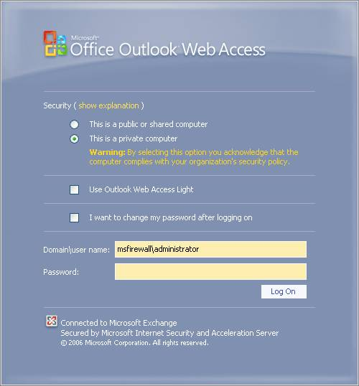
Figure 6
Notice that you have the following options:
- This is a public or shared computer The user should use this option when connecting from a computer that isn’t a corporate managed machine.
- This is a private computer The user should use this option when connecting from a corporate managed machine
- Use Outlook Web Access Light The use should select this option when connecting from a Web browser that isn’t Internet Explorer 6.0 or above, or if the user is on a very slow connection. We’ll look at the user experience with the option later
- I want to change my password after logging on This option enables the user to change his password from within the OWA interface
- Domain\user name The user must use the Domain\user name or the username@domain.com format to connect to the Exchange Server. If you use RADIUS authentication, they must always use Domain\user name. If you use Basic authentication, the user can enter just his user name (and password, or course).
- Password The users password is entered here
When you log on you’ll see the OWA site appear, as seen in the figure below.
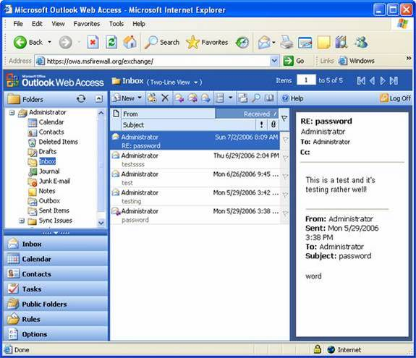
Figure 7
When you click the Log Off button in the OWA interface, you’ll see the log off page as seen in the figure below.
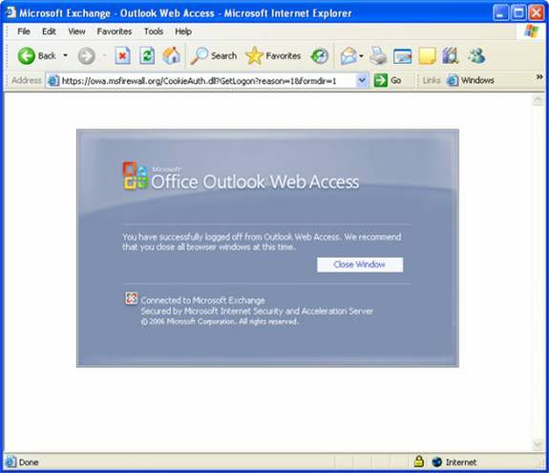
Figure 8
Let’s take a look at the Outlook Web Access Light user experience. The user selects the Use Outlook Web Access Light option in the OWA log on page and enters his credentials.
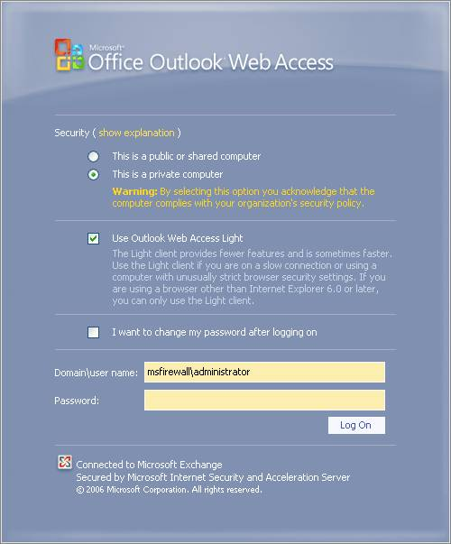
Figure 9
The OWA mailbox appears in the browser with a less functional user interface.
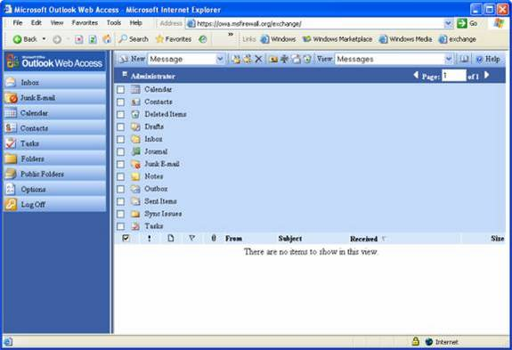
Figure 10
Now let’s look at what happens when the user chooses to change his password. On the OWA log on page, the user selects the I want to change my password after logging on option and enters his credentials.
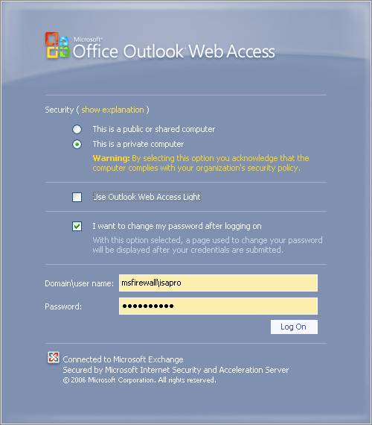
Figure 11
A change password page appears where the user enters his old password, and then types his new password twice. Then he clicks the Change Password button.
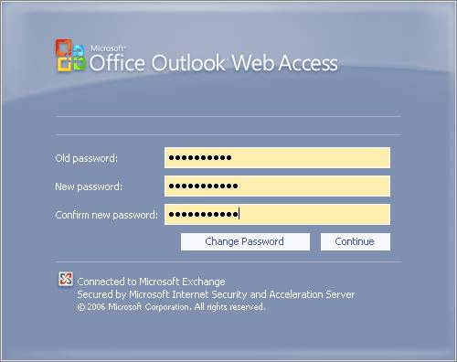
Figure 12
After clicking the Change Password button, a page appears that informs the user that the password was changed and that the user will be automatically redirected to his mailbox. If the user is not automatically redirected, he can click the Continue button.
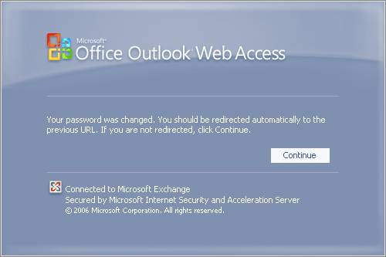
Figure 13

